Covid PERSONAL TIMELINE
This timeline is a reflective exercise where we are invited to reflect upon our life during co-vid. Sit with the following timeline. It begins pre-pandemic and to the future. Please add your own timeline on the bottom. Your timeline may include some of the following:
Significant Life Events, Celebration (health, graduations, accomplishments), Loss/Lament/Grief, Sickness, Death Events
Any Feelings (loneliness, depression, happy, grateful, lost, stressed, discouraged, etc.). Recognize the ups and downs of your life.
Mental and Social health issues
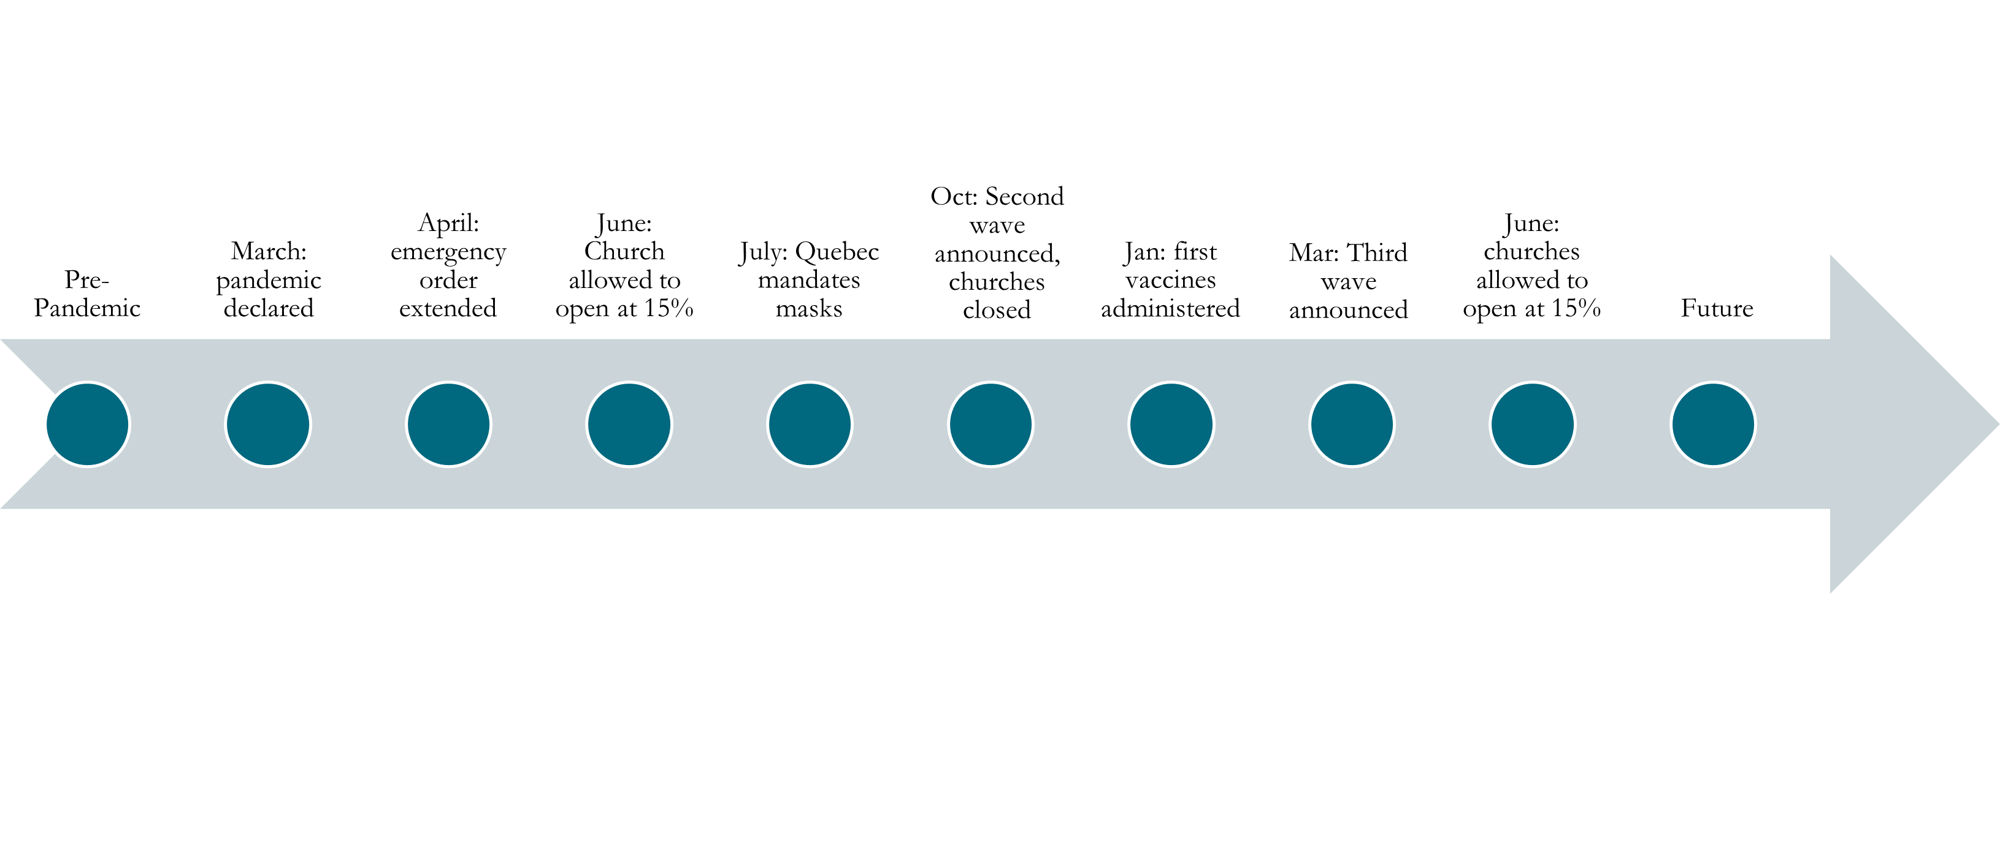Reflection Questions
How was your life pre-pandemic? What was your overall health like?
What brought you life?
As you look at your timeline, is there anything that you need to sit with and bring to God in prayer?
How do you want to live differently as things begin to reopen?

